Db2API: A Low-Code Platform for Rapid API Development

Raj Dineshbhai Adroja
Department of Computer Engineering
San Jose State Universituy
San Jose, United States
rajdineshbhai.adroja@sjsu.edu
Dhruvil Jayani
Department of Computer Engineering
San Jose State University
San Jose, United States
dhruvil.jayani@sjsu.edu
Johhny To
Department of Computer Engineering
San Jose State University
San Jose, United States
johhny.to@sjsu.edu

Bill Li
Department of Computer Engineering
San Jose State University
San Jose, United States
bill.li@sjsu.edu

Abstract— This paper introduces Db2API, a low-code platform that makes it easier for database-driven applications to generate APIs. The technology saves development time and effort by allowing users to implement CRUD and custom APIs and visually setup database structures. Db2API optimizes API speed and design with AI-driven recommendations. Scalability and efficiency are guaranteed by its AWS deployment and React, Fastify, and MongoDB architecture. The platform is a useful tool for businesses and developers because it speeds up time-to-market and increases developer productivity.
Keywords— API generation, low-code development, database-driven applications, artificial intelligence

Introduction
Database-driven API development and deployment are challenging for enterprises in today's fast-paced technology environment. Db2API is a low-code solution that allows developers establish unique API endpoints for database interaction as well as create, read, update, and delete (CRUD) APIs. The platform meets the increasing demand for quick API development by combining sophisticated frameworks with AI suggestions, making it usable by both inexperienced and seasoned developers. Backend development time is greatly decreased by Db2API, which also guarantees scalability, speeds up prototyping, and incorporates performance improvements based on real-time AI-driven insights. The architecture, goals, and technologies of the Db2API project are examined in this paper, along with how it might advance traditional API development techniques. By enabling intelligent features like natural language-based API generation and optimization, the integration of AI technologies, like OpenAI's ChatGPT, can enhance low-code platforms and further cut down on development time and effort.

Project idea
There is a growing need for efficient API development tools because of the growth of data-driven applications. API development has historically required extensive backend knowledge, manual optimizations, and repeated coding jobs. In high-pressure settings where time-to-market is crucial, like startups and corporations, these difficulties are exacerbated. Tools that may reduce complexity and boost productivity while bridging the gap between database management and API development are essential for developers.
To meet this demand, Db2API presents a low-code platform made especially for creating database APIs. In contrast to conventional development tools, Db2API offers a graphical user interface that enables users to design data models, configure database connections, and personalize API endpoints without the need for code. Furthermore, the incorporation of AI-powered suggestions guarantees that the produced APIs are scalable, reliable, and performance-optimized.
The architectural foundation, technical elements, and function of Db2API in speeding up API development are all covered in detail in this article. It also highlights how the platform is a vital tool in contemporary software development since it enables developers to build reliable, database-driven applications without requiring a great deal of backend knowledge.

Related Work
The idea of automating database API generation has been extensively investigated in both industry and academia. Several frameworks and technologies have been created to make managing database interactions and creating APIs easier. However, the automation, customization, and scalability of most current options are limited. This section showcases Db2API's unique selling points as well as noteworthy works and tools in the field.

1. Swagger (OpenAPI):
Swagger offers a strong foundation for creating, developing, and documenting APIs and is currently a part of the OpenAPI movement. Swagger creates interactive documentation and server stubs while developers manually write the API requirements using YAML or JSON. A low-code or no-code interface for automatically creating APIs from pre-existing database schemas is absent from Swagger, nevertheless. Furthermore, it doesn't support bespoke routes or provide AI-driven optimization.

2. Postman:
Developers can manually define and test API calls with Postman, which is frequently used for API testing and development. Although it has tools for building and maintaining APIs, it lacks database schema integration and automatic CRUD generation. Instead of automating backend development, Postman emphasizes testing and teamwork.

3. LoopBack Framework:
An open-source Node.js framework for creating APIs is called LoopBack. It enables developers to connect to a range of databases and create APIs using pre-existing data models. Even though it offers a certain amount of automation, defining models and associations still needs to be done by hand. Furthermore, AI-powered suggestions for performance tuning or optimization are not integrated.

4. Hasura:
Hasura is a well-known GraphQL engine that offers PostgreSQL databases with immediate APIs.[3] It offers features like real-time updates and permission rules and is excellent at automatically creating GraphQL APIs. Its focus is restricted to GraphQL APIs, though, and it lacks the ability to easily generate REST APIs or custom endpoints.

5. Firebase:
Google Firebase makes backend development easier by offering hosting and a real-time database. Although it is closely linked with Firebase's ecosystem, it enables developers to swiftly include database-driven functionalities. It is not flexible enough to generate APIs for bespoke schemas or integrate with external databases.

6. Research on Low-Code and No-Code Platforms:
The creation of low-code and no-code platforms to speed up software development has been studied by academics. With the help of these platforms, users may create applications using visual interfaces without having to write a lot of code. However, rather than concentrating on API production explicitly, most of the research concentrate on generic application development. Mendix and OutSystems, for instance, are low-code platforms with a generic purpose but are not experts at automating the building of database-driven APIs.[7]

7. AI-Driven Recommendations:
Tools with AI capabilities, like OpenAI's Codex, have surfaced to help engineers write code. Depending on the situation, these tools offer recommendations and code completions. Despite their strength, they do not incorporate database-specific optimizations or provide end-to-end solutions for API generation. Similar AI capabilities are used by Db2API, which focuses on customized suggestions for API performance and design based on database schemas.

Literature Survey
A crucial component of contemporary software engineering is the creation of APIs for database interaction, and researchers and industry professionals have investigated a few methods to automate this procedure. Three main topics are covered in the literature review: automated tools for generating APIs, low-code and no-code development platforms, and the incorporation of artificial intelligence into software engineering. The Db2API platform is based on the foundation of these investigations.[4]

Platforms for Low-Code and No-Code Development:
By offering visual interfaces for application design and deployment, low-code and no-code platforms seek to simplify software development. By abstracting away the complexity of programming, these platforms allow non-technical individuals to participate in software creation, according to research by Dragoni et al. (2020).[2] In this area, tools like Mendix and OutSystems have become more well-liked. However, rather than generating APIs, these platforms frequently concentrate on developing general-purpose applications. In order to meet specialized needs, including API development for database-driven applications, Martins et al. (2021) stress the need of domain-specific low-code platforms. Existing platforms streamline workflow and frontend automation, but there is a clear lack of backend-specific solutions, especially for API development.

Generate APIs Automatically:
Tools and frameworks for automating API development have been the subject of numerous research. For example, a framework for creating REST APIs from database schemas is shown in research by Khan et al. (2019).[1] This framework creates simple CRUD (Create, Read, Update, Delete) APIs by using schema introspection. It isn't flexible enough to implement unique routes or optimize APIs according to certain use cases, though.
The use of declarative programming for API generation is covered in another paper by Wu et al. (2021). This approach allows developers to provide high-level configurations that the system converts into functional APIs.[7] Even while this method needs less manual labor, it still necessitates a high level of technical expertise, which limits its usability for non-technical users.
By adding a low-code visual interface, Db2API expands on these concepts and makes it possible for even non-developers to create APIs effectively. It also supports AI-driven recommendations and configurable paths, going beyond CRUD activities.

Software Engineering and Artificial Intelligence:
The use of AI in software engineering has grown significantly in recent years. Ahmed et al.'s research from 2022 emphasizes the use of AI models for code generation and refactoring, such as OpenAI's Codex.[8] These tools help developers by automating repetitive operations and suggesting code. Nevertheless, their usefulness is restricted to discrete code fragments rather than comprehensive API generating solutions. Recent developments in AI, like ChatGPT from OpenAI, show how natural language processing can make developing APIs easier. For example, by analyzing user descriptions and offering efficient code snippets for particular use cases, ChatGPT can be used to dynamically construct APIs.
AI-driven technologies have been demonstrated to boost software system performance optimization by examining usage trends and making recommendations for improvements (Zhao et al., 2020). This method is used by Db2API to provide AI-powered suggestions, including pointing out bottlenecks in database queries or recommending caching strategies for particular endpoints. The gap between automation and optimization is closed by this AI integration.

Database-Driven API Development Challenges:
Schema compatibility, Making sure that when database schemas change, APIs continue to work (Pratt et al., 2018).
Performance bottlenecks: Making APIs more efficient for use cases requiring a lot of concurrency (Nguyen et al., 2019).
Concerns about security: Protecting APIs from flaws like SQL injection and illegal access (Li et al., 2020).
These studies highlight the necessity of instruments that tackle these issues. To address these problems, Db2API integrates built-in security measures, AI-based performance tweaking, and schema introspection.

Present Research Gaps: Despite notable advancements in API automation and low-code platforms, the following gaps still exist: AI Integration for API Design: AI is rarely used by current platforms to create or improve database-structure-based APIs.

Custom Endpoint Flexibility: Tools do not support complicated custom endpoints; instead, they are primarily focused on auto-generating CRUD activities. User Accessibility: Since many tools necessitate technical knowledge, non-developers cannot use them.
By fusing an intuitive user interface with AI-driven insights and support for both CRUD and bespoke API development, Db2API fills these gaps.

Technologies Used
Db2API's strong technology stack, which blends contemporary frameworks and technologies to provide a flawless user experience, is responsible for its success:

React: The user interface is powered by React, which provides a very responsive and interactive environment for setting up databases and creating APIs. React is perfect for creating a scalable frontend because of its component-based architecture, which guarantees reusability and maintainability.

MongoDB: MongoDB is the main database used to store schema definitions, API metadata, and user-defined configurations. Because it is NoSQL, schema design can be flexible to meet the needs of a wide range of applications.

ChatGPT: ChatGPT adds an artificial intelligence (AI) layer to the platform and offers wise suggestions for improving API architecture and queries. This feature guarantees effective database interactions by improving the efficiency of produced APIs. Users could take advantage of AI-driven suggestions for building unique endpoints and streamlining database interactions by integrating ChatGPT into Db2API. Non-technical users can specify API requirements without knowing how to code thanks to ChatGPT's ability to parse natural language inputs. The backend design might incorporate an extra ChatGPT-powered module. Using natural language descriptions, this module would create unique API routes, assess user input, and offer recommendations for performance enhancement. These AI-driven tasks may be executed securely thanks to the interface with AWS Lambda.

Amazon Web Services' scalability and dependability are utilized by hosting the backend services on AWS EC2 instances. By doing this, the platform is guaranteed to be able to manage an increasing number of users and simultaneous requests for API generation.

Fastify: The main backend framework for creating APIs is called Fastify. Fastify, which is well-known for its effectiveness and speed, makes it easier to create endpoints dynamically while using minimal resources.[6]

Together, these technologies provide a unified, high-performing platform that satisfies the requirements of contemporary API development.

GitHub Oauth:
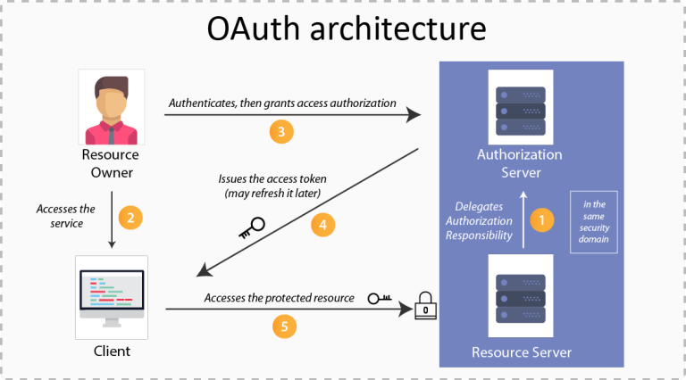
Fig 1. OAuth Architecture

For safe and easy user authentication, the site makes use of GitHub OAuth. Users can log in using their GitHub accounts thanks to the implementation of OAuth 2.0, an industry-standard protocol. By ensuring that the platform never handles user credentials directly, this integration improves security and privacy.[3] Consent-based access to user resources is made possible by Db2API's usage of GitHub OAuth, allowing for features like secure API management and customized settings. The approach ensures a strong and scalable authentication system by using API Gateway for access token validation and AWS Cognito for user pool management. In keeping with the current technologies and AWS infrastructure that you indicated in your report, this enhancement emphasizes the usage of GitHub OAuth in your platform.

System Architecture
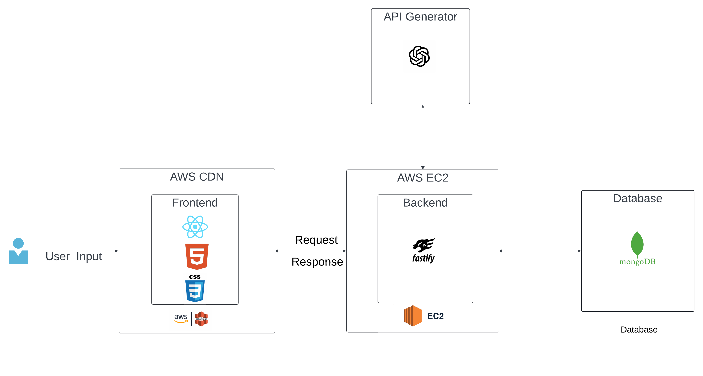
Fig 2. System achitecture
Scalability, performance, and user-friendliness are guaranteed by the modular architecture of the Db2API platform. The solution combines a few technologies to provide AI-driven optimization recommendations and automate the creation of APIs from database schemas. Every element is essential to provide users with a flawless experience.
The platform starts with a web-based interface designed with React and augmented with HTML and CSS for styling and structure. Users worldwide may access the frontend quickly and reliably thanks to its hosting on AWS CloudFront, a Content Delivery Network (CDN). Users can define schemas, request custom APIs, and configure database connections using this interface. After the user enters the required information, the backend receives it as RESTful requests to process.

Fastify, a high-performance Node.js framework, was used to construct the backend, which is housed on AWS EC2 instances. It functions as the platform's central processing unit and oversees creating custom APIs and CRUD activities in accordance with user specifications. To offer more sophisticated functionality, the backend also interfaces with an AI-powered API Generator (via ChatGPT). These consist of advice for framework-specific templates, performance optimization for APIs, and automatic code generation for bespoke routes. Using intelligent insights, our AI integration guarantees that the system not only makes creating APIs easier but also improves performance.

Because of its scalability for read-and-write-intensive operations and flexibility in managing dynamic schemas, MongoDB is used at the database layer. MongoDB acts as the main repository for the backend’s generation and validation of APIs and contains user-specific schema configurations.[8] To process user requests and save API setups, the backend interacts with MongoDB, guaranteeing a seamless workflow.

The architecture's integration of AI is one of its most notable aspects. The API Generator automatically generates efficient APIs by analyzing user-supplied inputs and database structures. Based on comparable use cases, this module can also recommend enhancements to the scalability, query performance, and layout of the API. The platform is incredibly user-friendly for both technical and non-technical users due to the AI's ability to comprehend and create unique API routes from user descriptions.

The system is extremely scalable and built to meet demands at the enterprise level. Low latency and high availability are guaranteed by AWS services like CloudFront and EC2. Additionally, the system is modular, which enables the inclusion of extra services, like load balancing to divide incoming traffic, if needed. This sturdy and adaptable architecture is designed to save development costs, speed up application time-to-market, and make it simple for businesses to create database-driven apps.

Solution
- Platform Design:
The Db2API platform is made to provide a strong backend together with an easy-to-use interface. Through a React-based interface, users may configure databases, establish schemas, and alter APIs while interacting with the platform. With the help of Fastify, the backend incorporates AI suggestions for performance optimization and dynamically creates APIs based on user input.

- Workflow:

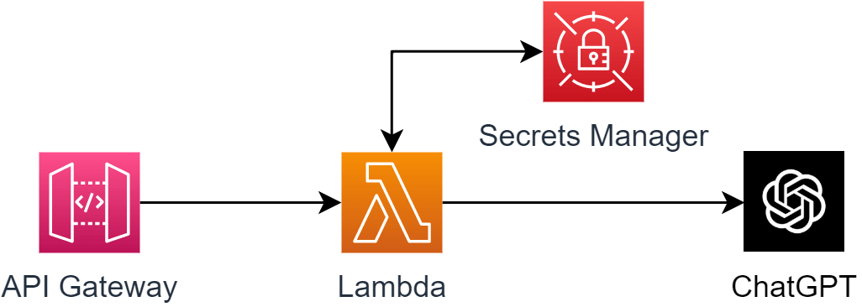
Fig 3. AI Integration

Database Connection: Users supply their database's connection information, such as credentials and schema definitions.
Schema Analysis: To comprehend the structure and relationships of the database, the platform examines the schema.
API Generation: Each schema's CRUD operations are generated automatically, and the backend exposes the endpoints. Custom Route Creation: Using descriptions in plain language that are converted into executable code, users can create custom routes.

AI Optimization: ChatGPT offers suggestions for improving caching systems, indexing plans, and API requests.

Custom Route Creation: An AI module (such as ChatGPT) processes user-provided natural language descriptions of desired endpoints to produce executable code.

Deployment: Generated APIs can be safely and extensively deployed with AWS Lambda and API Gateway. This method makes it easier to integrate with other apps and guarantees high availability.

- Deployment:
With AWS EC2, generated APIs may be immediately put into production, guaranteeing scalability and high availability. The platform also allows APIs to be exported as code packages for incorporation into already-existing projects.

Future Scope
Database Support Expansion: Although Db2API currently supports MongoDB, it will be expanded to include relational databases such as MySQL, PostgreSQL, and Microsoft SQL Server in subsequent versions, expanding the platform's user base.
Monitoring in Real Time: Users will be able to analyze API performance, spot bottlenecks, and make well-informed decisions regarding scaling and optimization with the introduction of real-time monitoring tools.
Mobile App: Db2API's mobile version will boost accessibility and productivity by enabling developers to manage APIs and configure databases while on the go.

Connectivity to DevOps Tools: The deployment process will be streamlined and compliance with contemporary development workflows ensured via a smooth connection with CI/CD pipelines and well-known DevOps tools like Jenkins and Docker.

Continuous improvement will be made possible by the insights that advanced analytics features will offer into API usage trends, error rates, and performance metrics.

AI Integration: To facilitate the development of natural language-based APIs, future iterations of Db2API may directly integrate with AI tools such as ChatGPT. This feature would increase efficiency and make the platform usable by non-developers.

Serverless Deployment: Adding serverless architectures utilizing AWS Lambda and API Gateway to Db2API's deployment choices would improve scalability and lower operating costs.

Conclusion
Db2API is a ground-breaking platform that combines AI-driven optimization with low-code design to streamline API development. It enables developers to create reliable, database-driven applications with little effort by automating repetitive activities and offering insightful recommendations. The platform will maintain its position as a top tool in the API development space as it develops thanks to its increased capabilities and enterprise features.

References
- A. S. Tanenbaum and D. J. Wetherall, Computer Networks, 5th ed. Upper Saddle River, NJ, USA: Pearson Education, 2011.
- M. Fowler, Patterns of Enterprise Application Architecture. Boston, MA, USA: Addison-Wesley, 2002.
- F. P. Brooks, "No Silver Bullet: Essence and Accidents of Software Engineering," Computer, vol. 20, no. 4, pp. 10-19, Apr. 1987.
- J. Dean and S. Ghemawat, "MapReduce: Simplified Data Processing on Large Clusters," in Proceedings of the 6th Symposium on Operating Systems Design and Implementation (OSDI), San Francisco, CA, USA, Dec. 2004, pp. 137-10.
- "React – A JavaScript Library for Building User Interfaces," Meta Platforms, Inc. [Online]. Available: https://reactjs.org/. [Accessed: 27-Nov-2024].
- "Fastify Documentation," Fastify. [Online]. Available: https://www.fastify.io/docs/latest/. [Accessed: 27-Nov-2024].
- R. M. Stallman, "Using and Porting GNU CC," Free Software Foundation, Boston, MA, USA, 1992.
- "MongoDB Documentation," MongoDB, Inc. [Online]. Available: https://www.mongodb.com/docs/. [Accessed: 27-Nov-2024].
- J. Kubiatowicz et al., "OceanStore: An Architecture for Global-Scale Persistent Storage," in Proceedings of the Ninth International Conference on Architectural Support for Programming Languages and Operating Systems (ASPLOS IX), Cambridge, MA, USA, Nov. 2000

